Assessing the Representativeness of an Oceanographic Reference Station Through Space and Time: Implications for Changes in Herring Spawning Grounds in Southwest Nova Scotia and the Bay of Fundy

_ compare historic late summer/fall GB with modern GB
-repeat analysis with prince 5 data the same to assess if the changes over time were consistent
-compare modern prince 5 with modern GB in time frame
-Compare modern prince 5 with modern SB in time frame
_ specify with Fred what data I want from him the next meeting!

Introduction
Within the 4VWX Atlantic herring stock complex, the Southwest Nova Scotia/Bay of Fundy (SWNS/BoF) component comprises distinct summer and fall spawning groups that spawn at discrete locations that have remained consistent over time. The two major spawning groups currently are Scots Bay (summer spawners; May-September) and German Bank (fall spawners; August-October/November). Historically, spawning stock biomass on German Bank averaged double that of Scots Bay (Storey, 1998) however these trends have reversed. Currently, German Bank is about a third of the spawning stock biomass estimated for Scots Bay (DFO, 2025: Figure 1). The drivers behind these differing changes have not yet been identified.
####
A major driver of trends in fish populations is recruitment success. Recruitment success is complex and remains poorly understood for Atlantic herring. There is not one sole factor that dominates in influencing recruitment success, but is a process that includes many factors, both biotic and abiotic which vary over space and time with interaction (Burbank, 2022). Temperature has been linked to recruitment Some of the abiotic factors that have been shown to effect recruitment success is temperature and stratification. Increased temperatures even by a few degrees has been shown to have a negative effect on larval survival (Sswat et al., 2018; Kho et al., 2023). Stratification is linked to larval behaviour and effects prey availability.
In 2017 the Herring Science Council began collecting oceanographic data on the spawning grounds in conjunction with the industry led acoustic surveys. This program has produced spatially consistent and high frequency recordings for the duration of the respective spawning seasons on each ground (Scots Bay and German Bank) with the use of Cast-Away CTDs (Hoskin Scientific). Previous to the HSC data collection, a sampling program to monitor the spatial distribution and abundance of herring larvae in the Bay of Fundy was established in 1972 by the Department of Fisheries and Oceans (DFO). Fall surveys were undertaken from 1975-1998 and spring surveys were conducted from 1975-1984 (Stephenson et al., 2015). An additional fall survey was conducted for one year only in 2009. From 1975-1987, standard MBT or XBT casts taken. Starting in 1988, Seabird’s CTD were used to collect continuous profiles of the water column (Stephenson et al., 2015).
With the current (HSC) and historic (DFO) dataset, a unique opportunity is presented to assess environmental changes on major herring spawning grounds between a period where the abundance of the SWNS/BoF herring stock was dominated by fall spawners, to the current period where there is now dominance of the summer spawning stock.

Historic data sets from north of Grand Manan (Bailey 1954) report salinity maximums of 33 PSS near bottom, with little seasonal variation, and surface minimums of 31 PSS. The minimum temperature observed was 0°C and maximum was 13°C in late summer. At the mouth of the Bay where there is extensive stratification, the salinity is about 33 PSS in the summer, but fresher at the surface. Surface salinity declines from the mouth of the Bay to near Cape Chignecto, where values of 30 PSS have been observed, and continuing up the Bay, 28 PSS in the Minas Basin. In the fall and winter when there is less fresh water run off, salinities tend to be higher and more spatially uniform. Surface temperatures in late summer show an increasing pattern from the mouth of the Bay to the Upper Bay into the Minas Basin. At the mouth of the Bay sea surface temperatures are on average 11°C warming to 14°C at Cape Chignecto, rising to 17°C in Chignecto and 21°C in the upper Minas Basin. In the fall, the temperatures are spatially more uniform and cooler than the summer. In the winter the gradient is reversed with the coldest water in the Upper Bay and warmest at the mouth of the Bay.
#Prince 5 trends

Study area and oceanographic setting
Southwest Nova Scotia (SWNS) and the Bay of Fundy (BoF) are part of the Gulf of Maine system (Figure 1) and are characterized by strong tides and associated currents, especially in the inner Bay of Fundy where tidal amplitudes are among the largest globally. Current speeds are typically on the order of ~1 m/s in SWNS and 1–1.5 m/s at the entrance of the Minas Channel, increasing to as high as ~4 m/s in the narrows near Cape Split (Greenberg, 1982). Strong tidal mixing produces predominantly well-mixed conditions in much of the Bay (including areas around Grand Manan, Brier Island, and SWNS), while stratification is seasonally reduced during late fall through early spring as surface heating weakens and meteorological forcing increases (Greenberg, 1982). Mean circulation in the upper Bay is largely tidally driven, whereas freshwater runoff plays a larger role in the lower Bay; wave energy in the Bay is typically low (Greenberg, 1982).
The presence of the historical oceanographic data collected by DFO and the recent data collection by the HSC provides a unique opportunity to investigate environmental change on herring spawning grounds over time, as well as investigate unique oceanographic differences between the individual spawning grounds within the same stock complex and management system.

Methods
Typically, samples were obtained every two weeks during their respective spawning seasons,which for Scots Bay started in May or June into September and for German Bank from August to October/November. Depth of the cast varied, with minimum acceptable cast depth of 30m, collecting a continuous profile of the water column. Data from each cast were downloaded from the device to a laptop using the program CastAway CTD v1.5 from Sontek. Each file was imported as a .csv and brought into R for analyses.

  - Study Area
Southwest Nova Scotia (SWNS) and the Bay of Fundy (BoF) are part of the Gulf of Maine system (Figure 1). This study focuses on major herring spawning grounds in these regions, including Scots Bay (outside the Minas Basin in the inner Bay of Fundy) and German Bank (southwest of Yarmouth, Nova Scotia).
On major herring spawning grounds in SWNS/BoF, annual monitoring of oceanographic conditions has not been collected on a systematic basis since 1998. In 2017 however, the Herring Science Council (HSC) began collecting oceanographic data on the spawning grounds in conjunction with the industry led acoustic surveys. This program has produced spatially consistent and high frequency recordings for the duration of the respective spawning seasons on each ground with the use of Cast-Away CTDs (Hoskin Scientific). These grounds include a spring/summer spawning population in Scots Bay outside the Minas Basin in the Inner Bay of Fundy and German Bank, a fall spawning population southwest of Yarmouth, Nova Scotia. Typically, samples were obtained every two weeks during their respective spawning seasons, which for Scots Bay started in May or June into September and for German Bank from August to October/November. Depth of the cast varied, with an aim to achieve at least 30m, collecting a continuous profile of the water column. Data from each cast were downloaded from the device to a laptop using the program CastAway CTD v1.5 from Sontek. Each file was imported as a .csv and brought into R for analyses.
  - Data
The modern data includes the years 2017-2024. The number of casts conducted per year varied, depending on the number of acoustic surveys as well as weather (Table 1). For the historical data, there were 8 years in the time series that matched the modern data in terms of seasonal timing. For German Bank, this was the period of julian day 221-300, spanning the spawning season from August to late October. This was thought to be a reasonable approach given the ocean conditions are often similar during that window with peak stratification and fall transition. Due to limited sampling effort in individual Late Summer and Fall periods at German Bank, these intervals (Julian Days 221–300) were combined into a single “late-season” category to improve annual sample sizes and reduce variability in seasonal estimates. This grouping is ecologically reasonable given the relatively gradual transition in hydrographic conditions across this period.
There was a great variety in number of casts per year (1-17). A label was attributed to sampling year to indicate data quality; years with less than 3 casts were considered weak and not used in analyses, years with 3-4 casts were classified as moderate and casts with 5 or more casts per year were considered strong (Table X).
Year | Ground | Sampling Window  Julian Day Range | Number of Casts | Useability
1977 | German Bank | 221-300 | 10 | Strong
1978 | German Bank | 221-300 | 2 | Weak
1979 | German Bank | 221-300 | 3 | Moderate
1980 | German Bank | 221-300 | 7 | Strong
1985 | German Bank | 221-300 | 1 | Weak
1989 | German Bank | 221-300 | 17 | Strong
1990 | German Bank | 221-300 | 5 | Strong
1993 | German Bank | 221-300 | 5 | Strong
2017 | German Bank | 221-300 | 3 | Moderate
2018 | German Bank | 221-300 | 4 | Moderate
2019 | German Bank | 221-300 | 10 | Strong
2020 | German Bank | 221-300 | 5 | Strong
2021 | German Bank | 221-300 | 4 | Moderate
2022 | German Bank | 221-300 | 6 | Strong
2023 | German Bank | 221-300 | 6 | Strong
2024 | German Bank | 221-300 | 4 | Moderate

The number of observations per cast varied significantly between the modern and historic data, chiefly due to differences in technological advancements in oceanographic sampling equipment from the historic to modern period. To help account for this issue, depth bins were established every 5m starting at 5m depth down to 30m. The 30m cut off was chosen as this is the depth where most of the modern cast’s end. In addition, the top 5m of every cast was trimmed to remove surface noise. Depth bins were retained if they were supported by at least three independent casts per year. This approach allowed inclusion of the full vertical structure while accounting for variability in sampling effort across years.

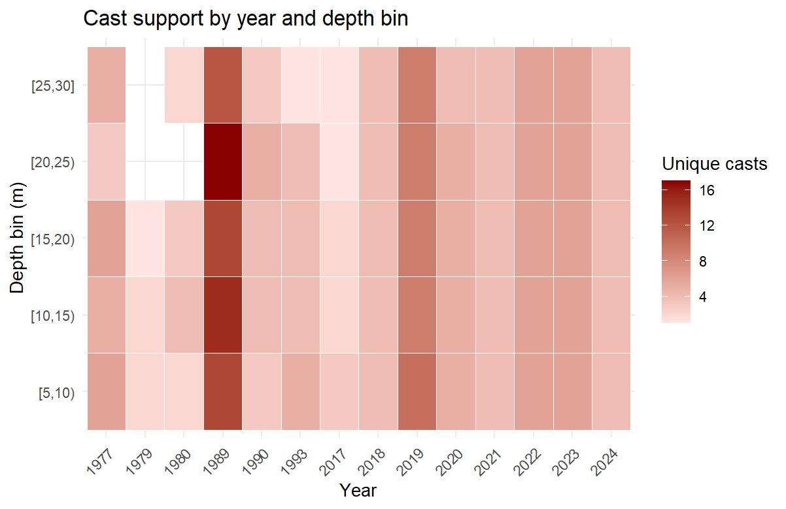
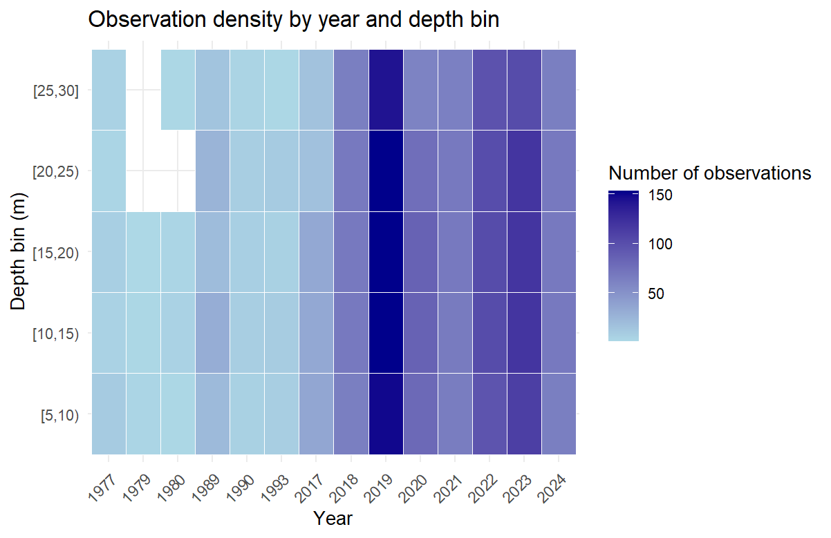

Results
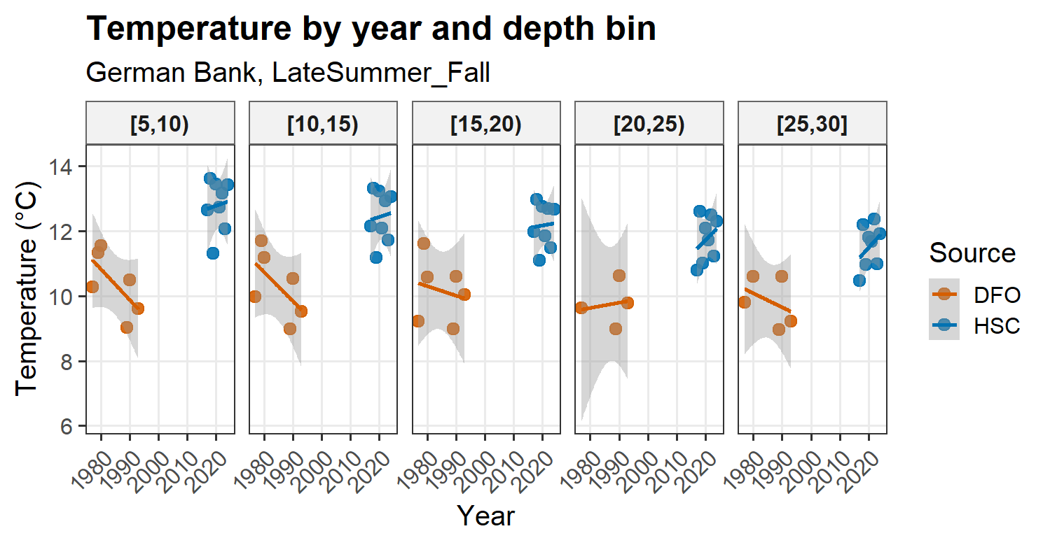
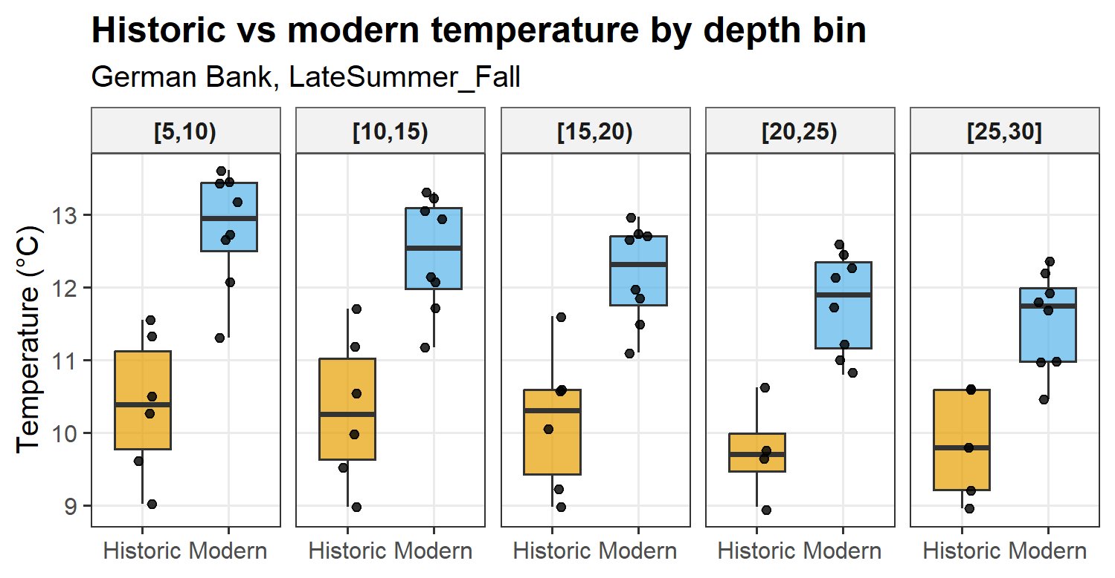
Modern late-summer/fall conditions at German Bank are warmer than historic conditions across the full sampled water column (5–30 m), with an offset of roughly ~1.5–2.5°C depending on depth bin. Historic and modern temperature profiles at German Bank indicated a coherent warming signal across the sampled water column (5–30 m). In every depth bin, mean modern temperatures were higher than mean historic temperatures, suggesting that hydrographic change was not restricted to near-surface waters but extended throughout the late-summer/fall profile.
Differences between historic and modern temperatures were assessed using linear regression with period as a categorical predictor and depth bin as a fixed effect. On average, modern temperatures are ~2.07°C higher than historic. In terms of depth bins, with 5-10m as a reference, 10-15 is not significantly different, weak decrease in 15-20 and more pronounced cooling from 20-30m. Vertical structure is consistent. Model fit is R² = 0.665, where as model explains 67% of the variance. Quite good for environmentally data given the limited historic years and natural variability. No red flags within the residual patterns, roughly symmetric. No obvious bias. There is a strong, statistically significant increase in temperature from the historic to modern period, independent of depth bin. This effect (~+2°C) is larger than the depth effect itself
Temperatures were significantly higher in the modern period compared to the historic period (estimate = +2.07°C, p < 0.001). Depth was also a significant predictor of temperature, with cooler conditions observed in deeper bins (20–30 m), although the effect size was smaller than the difference between periods. The model explained a substantial proportion of variance in the data (R² = 0.67).

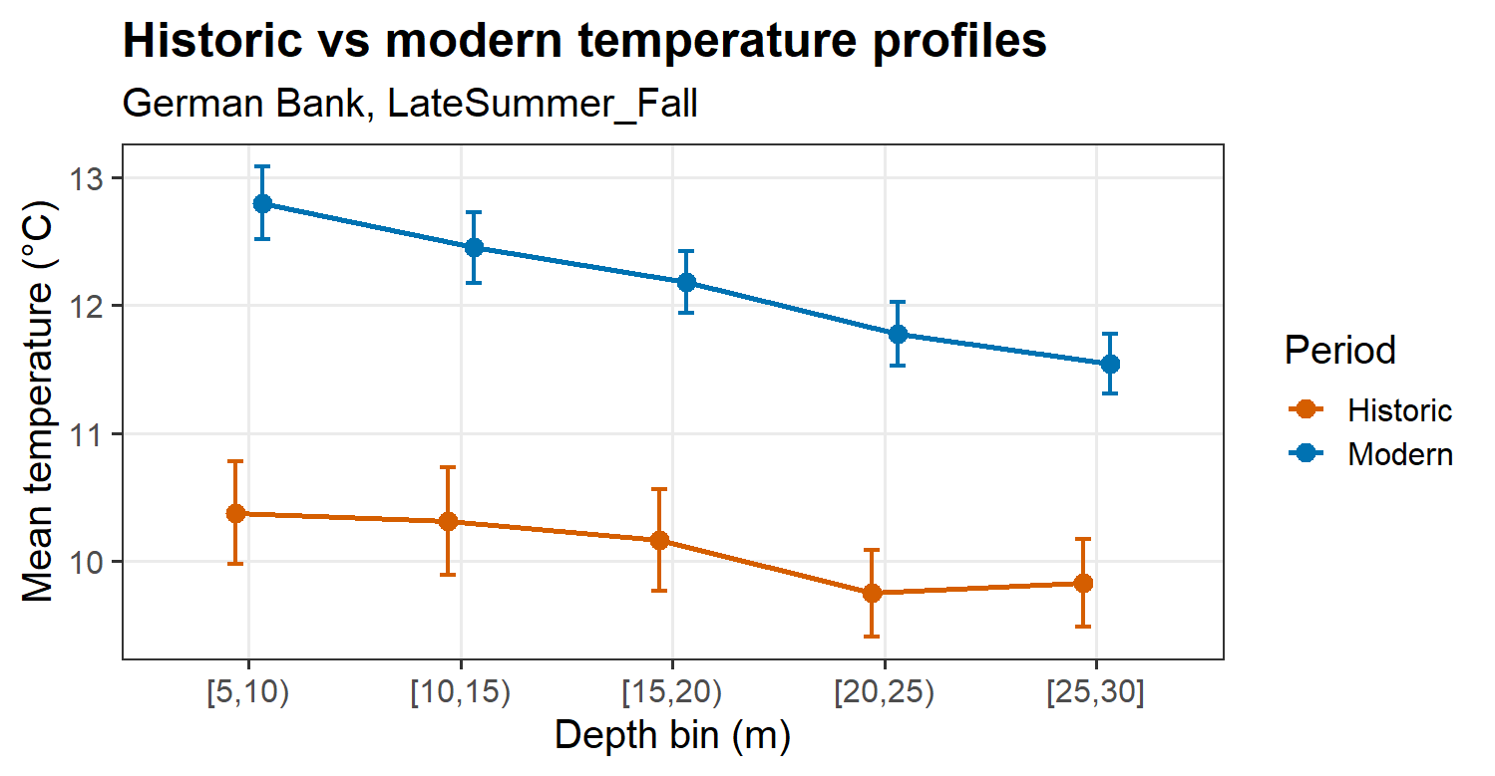

Discussion

The magnitude of warming between historic and modern observations (~2°C) exceeded the typical vertical temperature gradient across the 5–30 m water column, indicating a system-wide shift rather than a surface-restricted change.

Recruitment mechanisms for clupeiform fishes including Atlantic Herring are system specific and generalizations of climate drivers across systems should be avoided (Peck et al., 2013). This study shows that even within the same management system, the SWNS/BoF stock, oceanographic changes over time are not consistent between spawning grounds. The assumption that climate warming is consistent within a system over time is incorrect. This study has demonstrated that within the SWNS/BoF system, changes overtime in oceanographic conditions have not been consistent. Whereas in Scots Bay, oceanographic conditions have remained relatively stable over the last 40 years, on German Bank, the water has become warmer, fresher and more stratified.

herring spawning grounds that have been relatively buffered from the effects of climate change, whereas other grounds have become warmer and fresher.

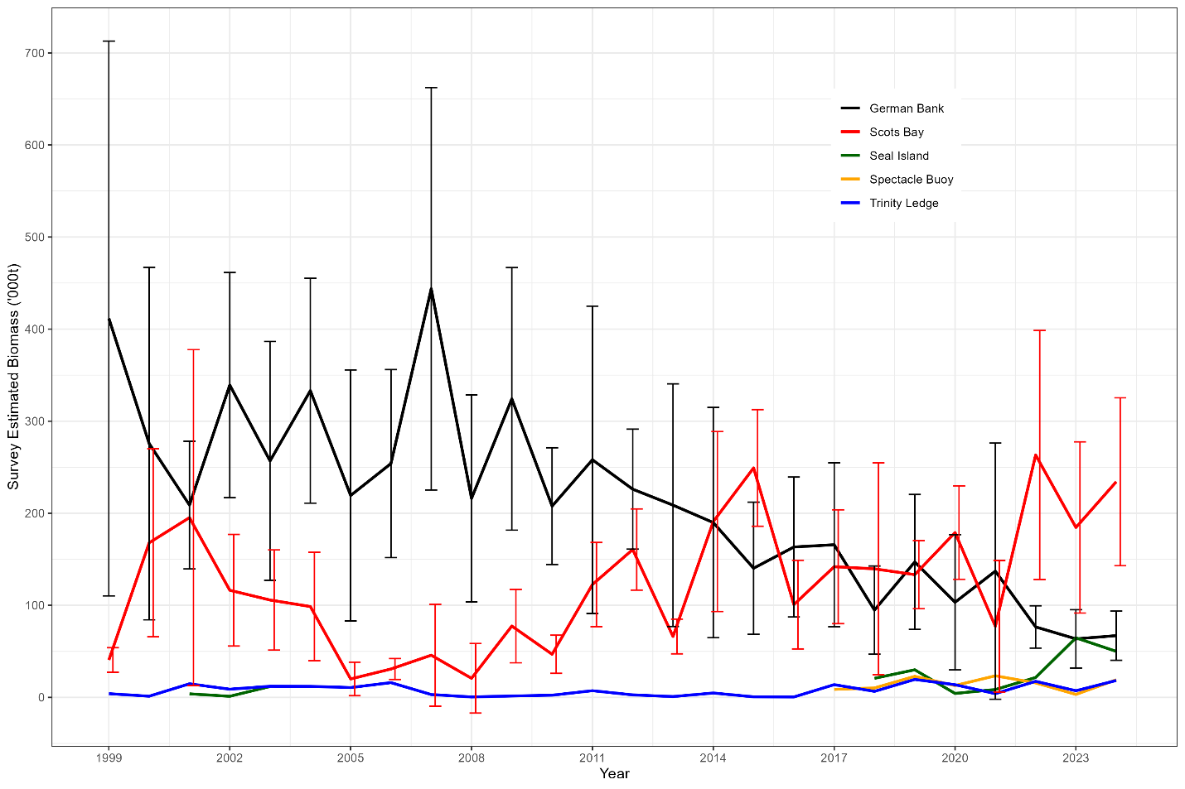
DFO (2025).
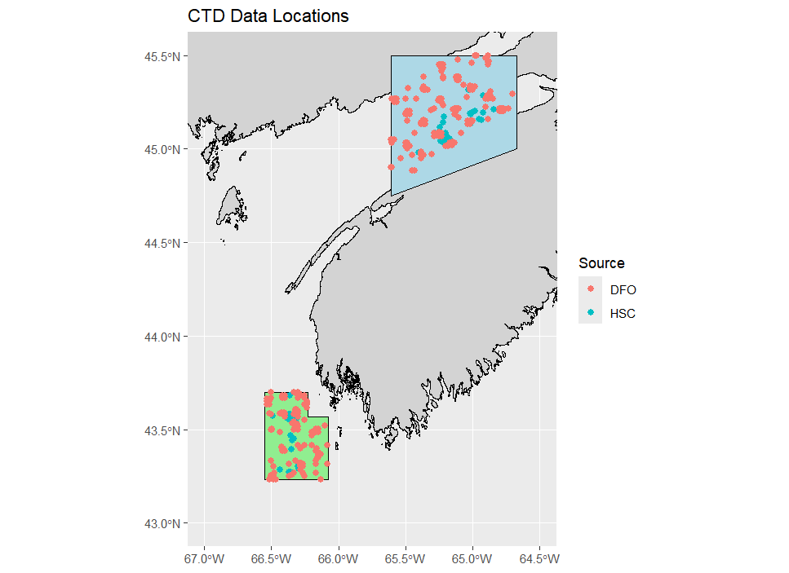
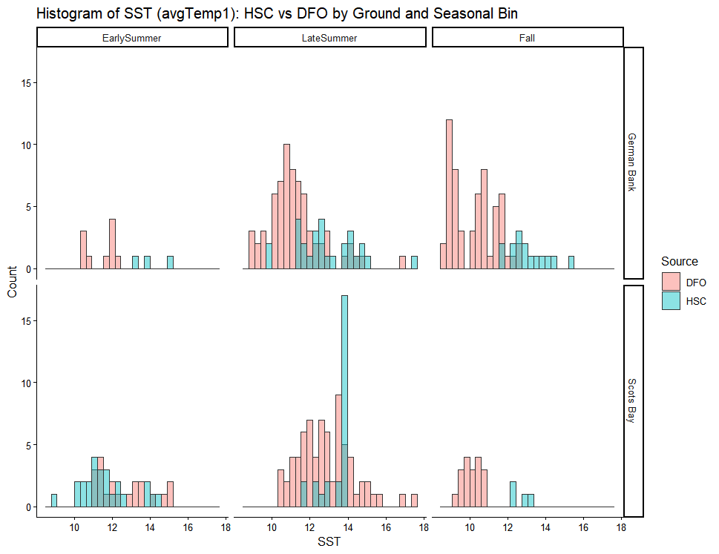
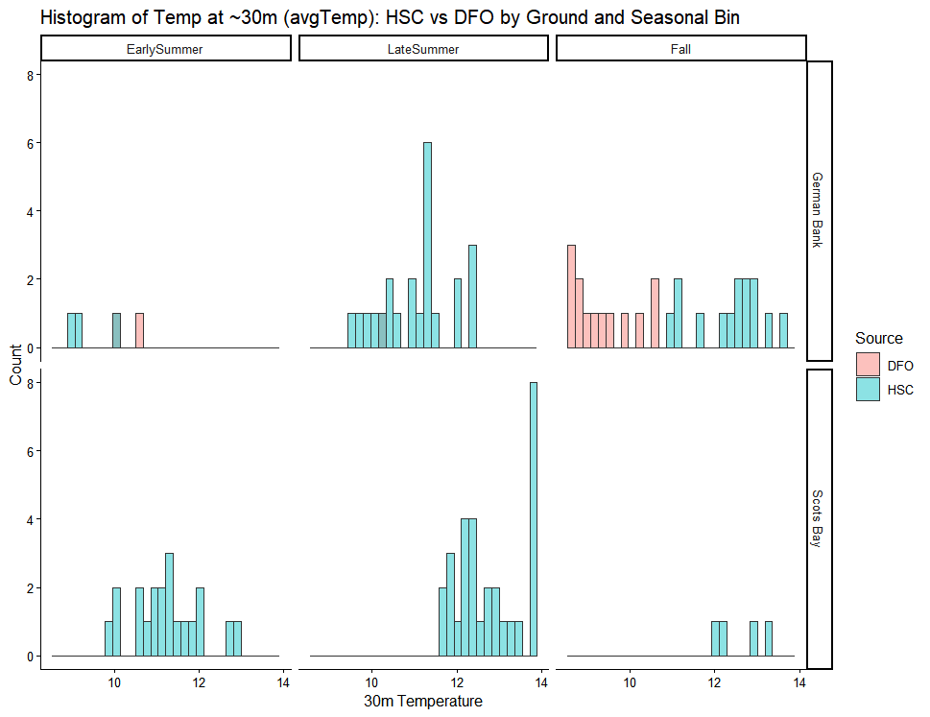
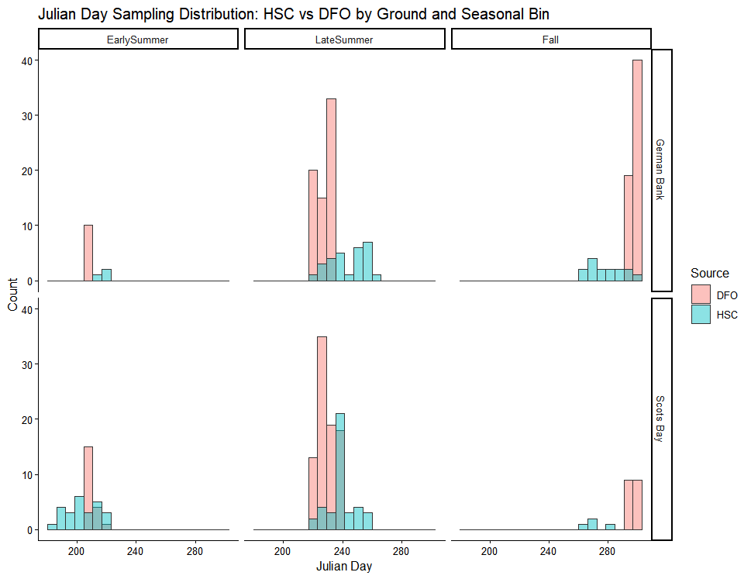

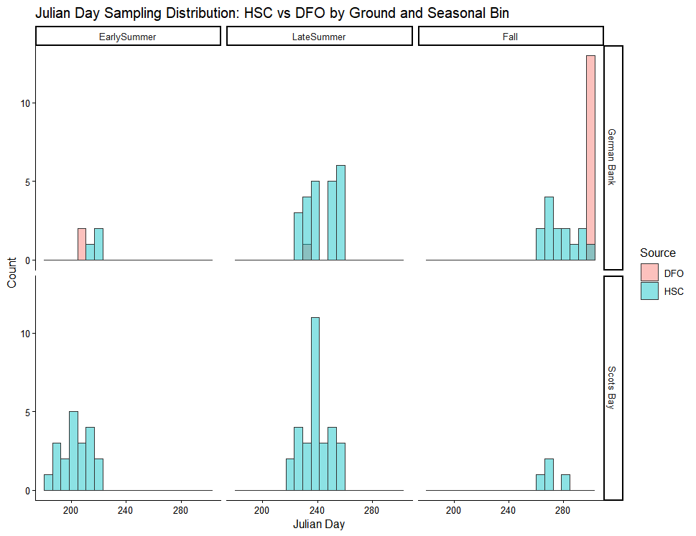

Results
German Bank has warmed by ~1.6 °C in late summer relative to historic conditions.
Again, this result is robust and statistically significant. German Bank is ~2.9 °C warmer in recent years (define) during the fall compared to the historic baseline. This shows consistent late-season warming on German Bank. In Scots Bay, there are no statistical differences in temperature in early or late summer at 0.01. Using a significance level of 0.05, Scots By was ~1 °C cooler in recent years compared to the historic baseline. For late summer in Scots Bay, there is no statistically significant difference between historic and recent SST in Scots Bay during late summer. German Bank has experienced significant late-season warming of ~1.5–3 °C relative to historic conditions, whereas Scots Bay shows no comparable warming and remains thermally stable across bins.

  - German Bank: warming + stratification + declining SSB
  - Scots Bay: stability + mixing + increasing SSB

At German Bank, sea surface temperature was significantly higher in the recent period compared to the historic baseline, with increases of approximately 1.6 °C in late summer and 2.9 °C in fall. In contrast, Scots Bay exhibited no evidence of comparable warming. Mid-summer temperatures in Scots Bay were slightly lower in the recent period, and late-summer temperatures did not differ significantly between historic and recent datasets. These results indicate strong spatial heterogeneity in long-term thermal change between spawning grounds.

Tables

Table X. Sample size of each bin for samples in the upper 5m of the water column.
Ground | Bin | Julian Day Range | DFO | DFO Years | HSC | HSC Years | Usable for Inference | Treatment
German Bank | Early Summer | 118-220 | 10 | 1979 | 3 | 2023-2025 | FALSE | NA
German Bank | Late Summer | 221-260 | 68 | 1977- 1980 | 28 | 2017- 2025 | TRUE | Unadjusted
German Bank | Fall | 261-300 | 59 | 1977, 1985, 1988- 1990, 1993 | 15 | 2018- 2024 | TRUE | Unadjusted
Scots Bay | Early Summer | 118-220 | 20 | 1979 | 25 | 2017-2024 | TRUE | Unadjusted
Scots Bay | Late Summer | 221-260 | 85 | 1977-1980 | 40 | 2017- 2025 | TRUE | Adjusted for Julian day
Scots Bay | Fall | 261-300 | 18 | 1977 | 4 | 2022-2024 | FALSE | NA

Table X. Sample size of each bin for samples at depth (~30m) and the stratification index.
Ground | Bin | Julian Day Range | DFO | DFO Years | HSC | HSC Years | Usable for Inference | Treatment
German Bank | Early Summer | 118-220 | 2 | 1979 | 3 | 2023, 2024, 2025 | FALSE
German Bank | Late Summer | 221-260 | 1 | 1980 | 23 | 2017-2025 | FALSE
German Bank | Fall | 261-300 | 13 | 1985, 1989, 1990, 1993 | 14 | 2018-2024 | TRUE
Scots Bay | Early Summer | 118-220 | 0 |  | 20 | 2017-2024 | FALSE
Scots Bay | Late Summer | 221-260 | 0 |  | 30 | 2017-2025 | FALSE
Scots Bay | Fall | 261-300 | 0 |  | 4 | 2022-2024 | FALSE

Table X. Seasonal Sampling Overlap and SST Differences Between Historic (DFO) and Recent (HSC) Observations.
Ground | Bin | Overlap  Width  (no. Days) | Overlap  Fraction | DFO  n | HSC  n | Seasonal Sampling Bias Flag p05 | Test Type | Mean DFO  °C | Mean HSC  °C | Effect  Estimate °C | p value | Significance at 0.01
German Bank | Late Summer | 10 | 0.27 | 68 | 28 | FALSE  (p=0.329) | Permutation test | 11.29 | 12.88 | 1.59 | 0.00 | ***
German Bank | Fall | 5 | 0.135 | 59 | 15 | FALSE  (p=0.828) | Permutation test | 10.25 | 13.09 | 2.85 | 0.00 | ***
Scots Bay | Early Summer | 9 | 0.243 | 20 | 25 | FALSE  (p=0.329) | Permutation test | 12.62 | 11.64 | -0.98 | 0.02
Scots Bay | Late  Summer | 17 | 0.447 | 85 | 40 | TRUE  (p=0.001) | GAM (Julian day adjusted) | 12.84 | 13.40 | 0.42 | 0.17

Table X. Seasonal Sampling Overlap and at Depth (30m) Differences Between Historic (DFO) and Recent (HSC) Observations.
Ground | Bin | Overlap  Width  (no. Days) | Overlap  Fraction | DFO  n | HSC  n | Seasonal Sampling Bias Flag p05 | Test Type | Mean DFO  °C | Mean HSC  °C | Effect  Estimate °C | p value | Significance at 0.01
German Bank | Fall |  |  | 13 | 14 |  | Permutation test | 9.35 | 12.30 | 2.99 | 0.00 | ***

SST
Bin | Bias severity
German Bank – Fall | Strong bias
Scots Bay – Early Summer | Moderate bias
German Bank – Late Summer | Mild bias
Scots Bay – Late Summer | Negligible bias

Within‑bin Julian‑day adjustment revealed that the influence of seasonal sampling timing on DFO–HSC temperature comparisons varied among bins and grounds. At German Bank in Fall, the large unadjusted temperature difference was substantially reduced after accounting for Julian day, indicating strong within‑bin seasonal bias. In contrast, Late Summer comparisons at both grounds were minimally affected by Julian‑day adjustment, suggesting that bin‑wise temperature differences in these cases were robust to seasonal sampling differences.
Within each seasonal bin, differences in SST between DFO and HSC were evaluated using Julian-day–adjusted models. Adjusted source effects, standard errors, and p-values are reported, allowing assessment of both the magnitude and statistical significance of SST differences after accounting for within-bin seasonal timing.
Within each ground and seasonal bin, differences in sea surface temperature (SST) between DFO and HSC were first summarized using unadjusted bin-wise means and then re-evaluated using models that adjusted for Julian day within the bin. The magnitude and influence of within-bin seasonal timing bias varied among bins and grounds. At German Bank in Fall, a large unadjusted SST difference (HSC warmer than DFO) was substantially reduced after adjusting for Julian day, indicating that much of the apparent bin-wise difference reflected unequal seasonal sampling within the bin rather than a source-related offset. In contrast, Late Summer comparisons at German Bank were only modestly affected by Julian-day adjustment, with adjusted estimates remaining similar to unadjusted values, suggesting a persistent difference between data sources. At Scots Bay, Early Summer comparisons showed a moderate reduction in the estimated SST difference after adjustment, indicating partial seasonal timing bias within the bin, whereas Late Summer comparisons were largely unchanged by Julian-day adjustment, demonstrating that this bin provided a robust basis for SST comparison. Overall, these results show that while seasonal binning constrained comparisons to broadly similar periods, the extent to which within-bin Julian-day coverage influenced SST differences depended on both ground and season, underscoring the importance of evaluating and accounting for residual seasonal timing bias within bins.
This analysis demonstrates that while seasonal binning is an effective first step for constraining comparisons between historic (DFO) and recent (HSC) SST observations, binning alone does not uniformly eliminate bias arising from differences in seasonal sampling timing. By explicitly evaluating and adjusting for Julian-day coverage within bins, we show that the influence of seasonal timing on DFO–HSC temperature comparisons varies by ground and season. In some cases, particularly Fall at German Bank and Early Summer at Scots Bay, large unadjusted differences were substantially reduced after accounting for Julian day, indicating that apparent source-related differences largely reflected unequal sampling within the seasonal bin rather than true temperature offsets. In contrast, Late Summer comparisons at both grounds were minimally affected by Julian-day adjustment, suggesting that these bins provide a robust basis for SST comparison. Together, these results highlight that seasonal bins should be viewed as defining the temporal scope of inference rather than guaranteeing comparability, and that residual within-bin seasonal structure can meaningfully influence temperature comparisons. Incorporating Julian-day adjustment within bins therefore provides a more reliable framework for assessing SST differences between data sources and avoids attributing phenological sampling effects to sensor or platform differences.
At German Bank in Fall, the large unadjusted SST difference between HSC and DFO was substantially reduced after accounting for Julian-day coverage within the bin, indicating strong seasonal timing bias. However, the adjusted difference remained statistically significant, demonstrating that while unequal seasonal sampling inflated the apparent magnitude of the difference, a persistent SST offset between data sources remained. This highlights the importance of distinguishing between the presence of seasonal bias and the statistical significance of adjusted source effects.

Column | Meaning
diff_adjusted | Estimated SST difference (HSC − DFO) after adjusting for Julian day within the bin
se_adjusted | Uncertainty in that estimate
p_adjusted | Test of whether the adjusted difference differs from zero
delta_due_to_JD | How much of the unadjusted difference was due to seasonal timing

The key reason: you changed what “seasonal bias” means
Your earlier GAM code was testing this question:
Within a bin and ground, do DFO and HSC differ in their Julian day distributions?
In other words:
- Response = JulianDay
- Predictor = Source
- Purpose = diagnostic of sampling timing bias only
This is a pure seasonal‐timing test, completely independent of SST.
That test answers:
“Are the two programs sampling the season at the same time?”
And in that framework, you found:
Only Scots Bay Late Summer showed strong evidence of timing bias.
That result is not wrong.

Your current within-bin GAMs are testing a different question:
Within a bin and ground, does unequal Julian-day coverage bias the temperature comparison between DFO and HSC?
Now:
- Response = SST
- Predictors = Source + s(JulianDay)
- Purpose = does timing confound the SST difference?
- This answers:
- “Does seasonal timing matter for SST inference within this bin?”
- This is a stronger, downstream question.
- Why these two questions give different answers
- This is the crux.
- Timing bias ≠ temperature bias
- You can have:
- Scenario | - Timing test | - SST bias
- Slight JD shift + steep seasonal SST slope | - Weak | - Strong
- Large JD shift + flat SST curve | - Strong | - Weak
- Moderate JD shift + moderate slope | - Moderate | - Moderate
- Your earlier test only looked at the x-axis (Julian day).
Your current analysis looks at x and y (SST).
- So it is entirely possible (and statistically normal) that:
- Only one bin shows statistically strong timing separation
- But multiple bins show meaningful SST confounding once timing is accounted for
- That is exactly what you are seeing.

- Why Scots Bay Late Summer showed up before
- Scots Bay Late Summer likely has:
- The cleanest, most consistent separation in Julian day
- Enough sample size
- Relatively simple structure
- So it popped out in a timing-only GAM.
- But that does not mean:
- “Other bins have no seasonal influence on SST”
- It only means:
- “The Julian-day distributions alone were not clearly separable at the chosen α”

- Why German Bank Fall shows bias now
- German Bank Fall is a classic case of this:
- Julian-day distributions overlap
- But SST changes rapidly through Fall
- Small timing differences → large temperature differences
- So:
- Timing-only test: may not flag strong bias
- SST-adjusted model: shows big reduction from 2.85 → 0.88 °C
- That is not a contradiction — it’s expected behaviour.

- Another subtle but important difference: α levels
- Earlier, you were often using:
- α = 0.01 or 0.001 for timing bias tests (very conservative)
- Now:
- α = 0.05 for SST inference
- That alone can change which bins are flagged.
- This does not mean you moved the goalposts — it means:
- Diagnostics were conservative
- Inference is conventional
- That’s a defensible workflow.

- One sentence that resolves the confusion
- Here is the mental model that usually makes this “click”:
- The earlier GAM asked “are the seasons sampled at the same time?”, while the current GAM asks “does sampling time matter for SST inference?”. Those are related but not equivalent questions.
- Once you see that, the results line up.

- How to explain this cleanly in your paper (recommended)
- You can reconcile this explicitly with one sentence (optional but powerful):
- Although timing-only analyses indicated strong seasonal sampling differences in only a subset of bins, subsequent within-bin SST models showed that even modest differences in Julian-day coverage could meaningfully influence temperature comparisons where seasonal SST gradients were steep.
- That sentence pre-empts reviewer confusion and exactly matches what happened.

- Bottom line (no contradiction)
- ✅ Your earlier GAM was correct
- ✅ Your current analysis is correct
- ✅ They answer different questions
- ✅ SST bias can exist even when timing bias is weak
- ✅ Scots Bay Late Summer is still special — just not the only bin where timing matters for SST
- If you want, next I can:
- help you map each analysis explicitly to a question in the Methods,
- help you decide whether to keep the earlier timing-only GAM in the paper, or
- help you add a conceptual figure or sentence that makes this obvious to readers.
- You didn’t make a mistake — you refined the question.

Earlier GAM = overlap test
- Response: Julian day
- Question: Are the seasons sampled at the same time?
- Output: Which bins are even usable
Current within-bin SST GAM = bias-in-temperature test
- Response: SST
- Question: Does timing bias the SST comparison within this bin?
- Output: How much bias remains, and whether SST differences persist
So the workflow is hierarchical, not conflicting.
Applying this to your deep dataset example
Step 1 — Earlier GAM (bin screening)
- Result: Only German Bank Fall showed acceptable seasonal overlap
- Conclusion:
Only this bin is defensible for SST comparison in the deep data
✅ This is still true
✅ You should keep saying this
Step 2 — Within-bin SST adjustment (bias quantification)
- Result:
  - Unadjusted SST difference was large
  - Julian-day adjustment reduced it substantially
  - Adjusted difference may or may not remain significant (depending on p)
This answers a different question:
Even in the only “legit” bin, how much of the difference is seasonal vs source-related?
That’s refinement, not contradiction.

A helpful way to think about it (mental model)
Think of the analyses as filters:
Filter 1 — Is the bin even usable? ✅
Earlier GAM
(seasonal overlap)
Filter 2 — Is the SST comparison biased within that bin? ✅
Current within-bin GAM
(seasonal confounding of temperature)
A bin must pass Filter 1 to even be considered.
Passing Filter 1 does not guarantee it will pass Filter 2.
German Bank Fall (deep data):
- ✅ Passes Filter 1 (usable)
- ⚠️ Shows substantial seasonal influence in Filter 2
That is a strong, nuanced result — not an inconsistency.
Seasonal-overlap analyses indicated that, for the deep temperature dataset, only the German Bank Fall bin provided sufficient overlap in sampling timing between DFO and HSC to support comparison. Subsequent within-bin analyses showed that even within this bin, differences in Julian-day coverage influenced SST estimates, highlighting the importance of evaluating both bin usability and residual seasonal bias.
Bottom line
- ✅ The earlier GAM was useful
- ✅ It correctly identified which bins were even defensible
- ✅ It did not claim those bins were unbiased
- ✅ The newer analysis refines, rather than contradicts, the earlier result
- ✅ Your conclusion about the deep dataset (German Bank Fall being the only usable bin) is still valid
You didn’t invalidate your earlier work — you built on it correctly.
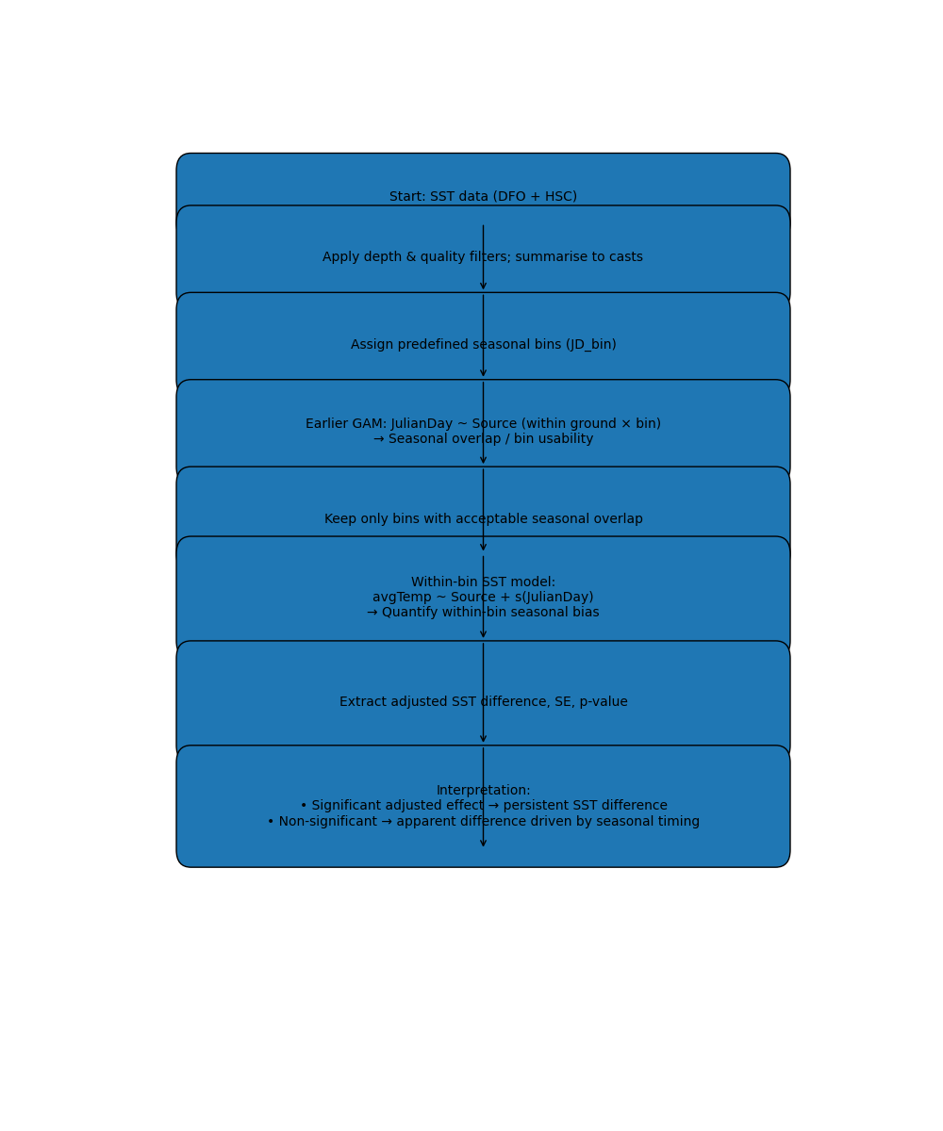
Flowchart logic
Step 1 — Data preparation
SST observations from DFO and HSC were first filtered for depth and data quality and summarized to the cast level to ensure comparable sampling units.
Step 2 — Seasonal binning
Casts were assigned to predefined seasonal bins (Early Summer, Late Summer, Fall) based on Julian day. Bins define the temporal scope of inference but are not assumed a priori to ensure seasonal comparability.
Step 3 — Bin usability / seasonal overlap diagnostic
An initial GAM with Julian day as the response and data source as the predictor was applied within each ground × bin combination. This analysis evaluated whether DFO and HSC sampled the same portion of the season within each bin and was used to identify bins with sufficient seasonal overlap to support SST comparison.
Step 4 — Bin selection
Only bins demonstrating acceptable seasonal overlap between data sources were retained for further SST analysis. For example, in the deep dataset, this screening indicated that German Bank Fall was the only bin with sufficient overlap.
Step 5 — Within-bin seasonal bias assessment
For retained bins, SST was modelled as a function of data source and Julian day using within-bin GAMs. This step quantified whether unequal Julian-day coverage within a bin biased the estimated SST difference between DFO and HSC.
Step 6 — Inference on SST differences
Adjusted SST differences, along with their standard errors and p-values, were extracted from the within-bin models. Statistical inference focused on the source effect after accounting for within-bin seasonal timing.
Step 7 — Interpretation
Bins in which adjusted differences remained statistically significant were interpreted as showing persistent SST differences between data sources, whereas bins with non-significant adjusted effects were interpreted as cases where apparent differences were largely attributable to seasonal sampling timing.

References
Greenberg, 1982/3?
DFO, 2025. 4VWX Herring (Clupea harengus) Stock Status Update to 2024. DFO. Can. Sci. Advis. Sec. Sci. Resp. 2025/026.
Kho, J., Delgado, M.L., McCracken, G.R. Munden, J. Ruzzante, D.E. 2023. Epigenetic patterns in Atlantic herring (Clupea harengus): Temperature and photoperiod as environmental stressor during larval development. Molecular Ecology (33).
Peck, M.A., Reglero, P., Takahashi, M., Catalán, I.A. 2013. Life cycle ecophysiology of small pelagic fish and climate-driven changes in populations. Progress in Oceanography 116: 220-245.
Oeberst, R., Dickey-Collas, M., and Nash, R. D. M. 2009. Mean daily growth of herring larvae in relation to temperature over a range of 5–20°C,based on weekly repeated cruises in the Greifswalder Bodden. – ICES Journal of Marine Science, 66: 1696–1701.
Sswat M, Stiasny MH, Jutfelt F, Riebesell U, Clemmesen C (2018) Growth performance and survival of larval Atlantic herring, under the combined effects of elevated temperatures and CO 2 . PLoS ONE 13(1): e0191947. https://doi.org/ 10.1371/journal.pone.0191947
Storey, S. 1998. Spatial-Temporal Fish Stock Assessment (Master’s Thesis). University of Ottawa 0-612-28463-8. MQ28463.pdf

